**Tropical Paradise Wallpaper in Teal**

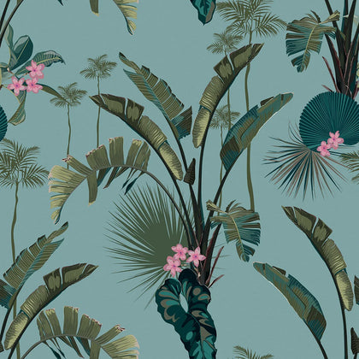Tropical paradise wallpaper in teal brings a vibrant and refreshing ambiance to any space, evoking the serene beauty of lush, exotic landscapes. The rich teal tones provide a soothing yet energizing backdrop, reminiscent of ocean waters and tropical foliage. Intricate patterns of palm leaves, flowers, and tropical motifs add depth and a sense of escapism, making it perfect for creating a bold statement wall. Ideal for living rooms, bedrooms, or even bathrooms, this wallpaper transforms interiors into a tranquil retreat, blending modern style with the natural allure of the tropics.